Url : sales/RFMaster.aspx sales RF

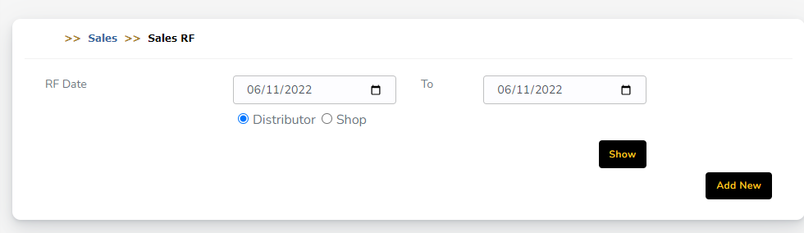

1. Show button is not working [Lots of issue found while inspect]

RF Add/Edit

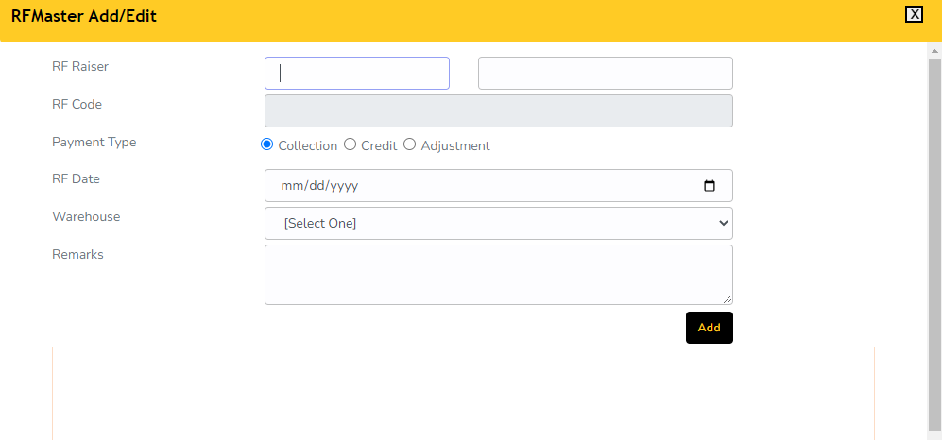

1. RF Raiser Text box data not loaded, that’s way RF Code not visible
2. Could not perform Add button

RFMasterInternal.aspx Internal RF

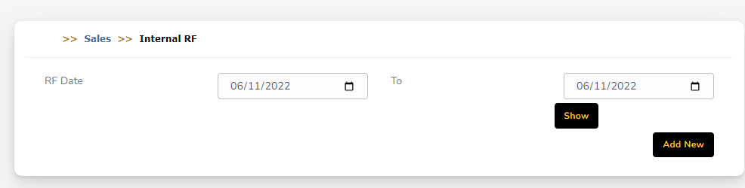

1. Show button is not working [Lots of issue found while inspect]
2. Show button not in right place

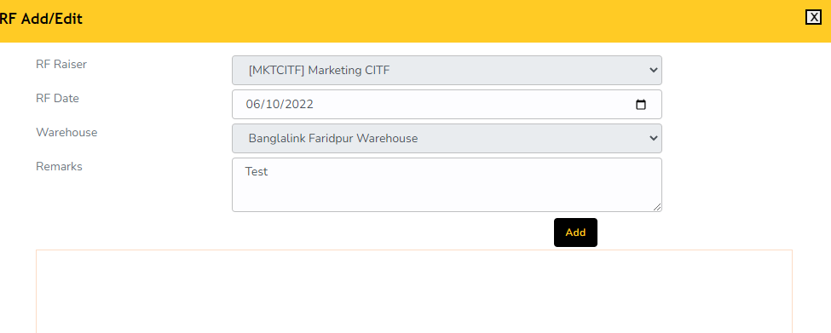Internal RF

1. Add button not in right place

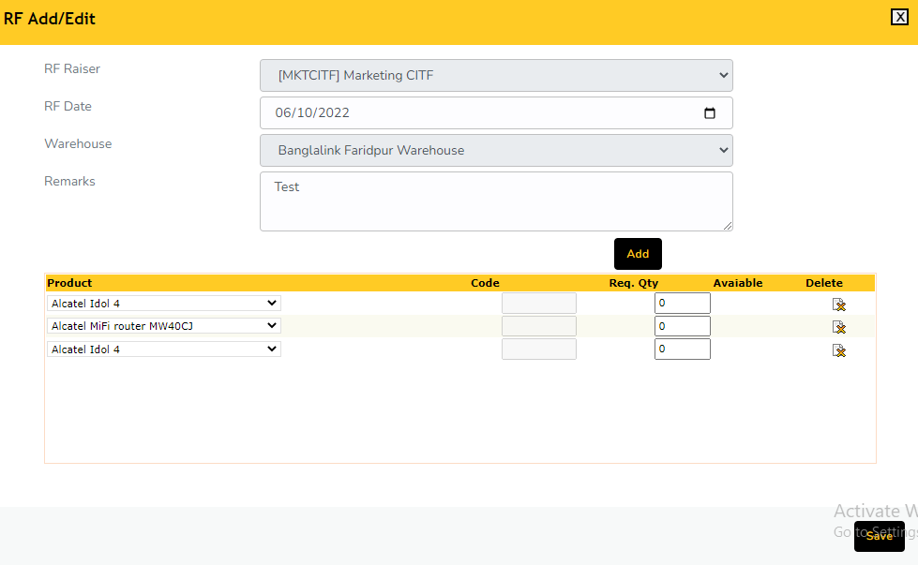

1. When select product Code & Available Qty not show
2. Data grid need to redesign
3. Not perform to save button

ItemReturn.aspx Material Return

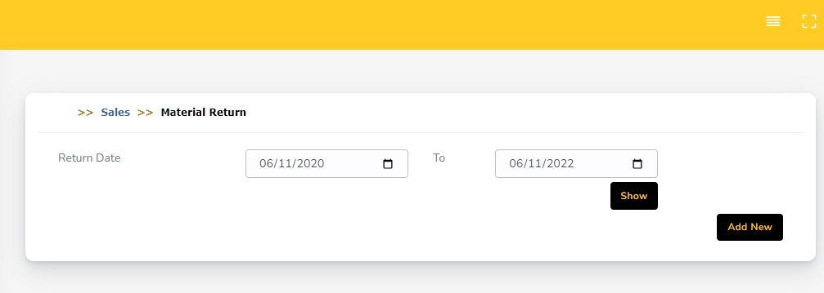

1. Show button is not working [Lots of issue found while inspect]

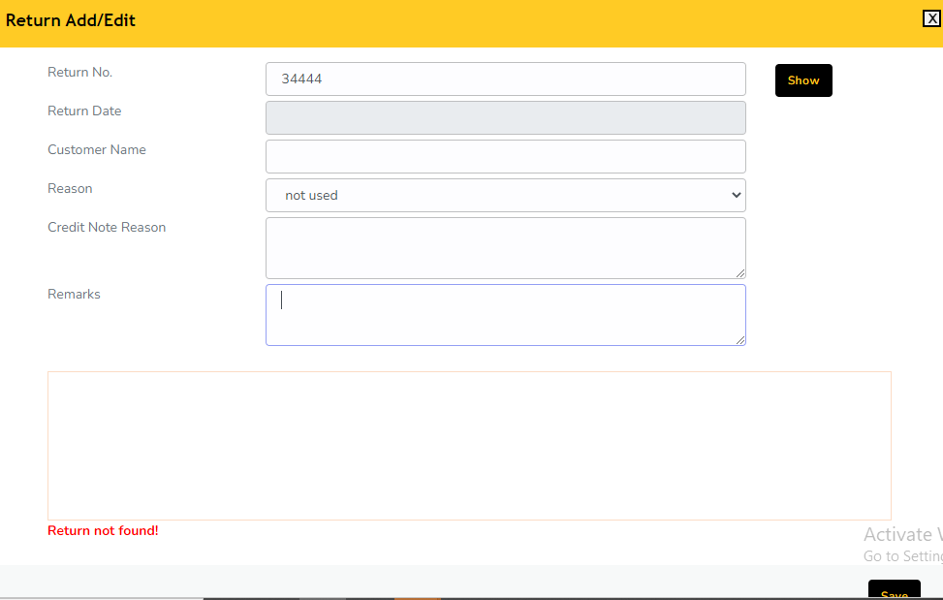

1. Return No. “Show” button not working
2. Return date not working
3. Could not perform save button

ReturnInvoice.aspx

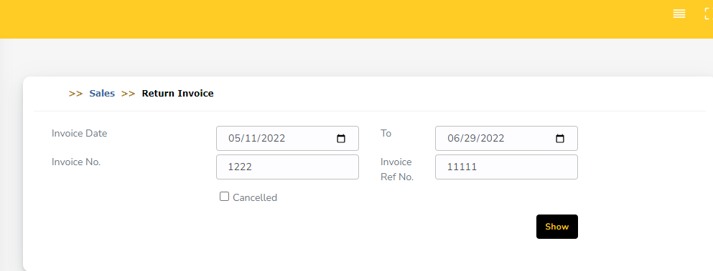

1. Show button is not working [Lots of issue found while inspect]
2. Could not perform popup page because data not show.

RFView.aspx

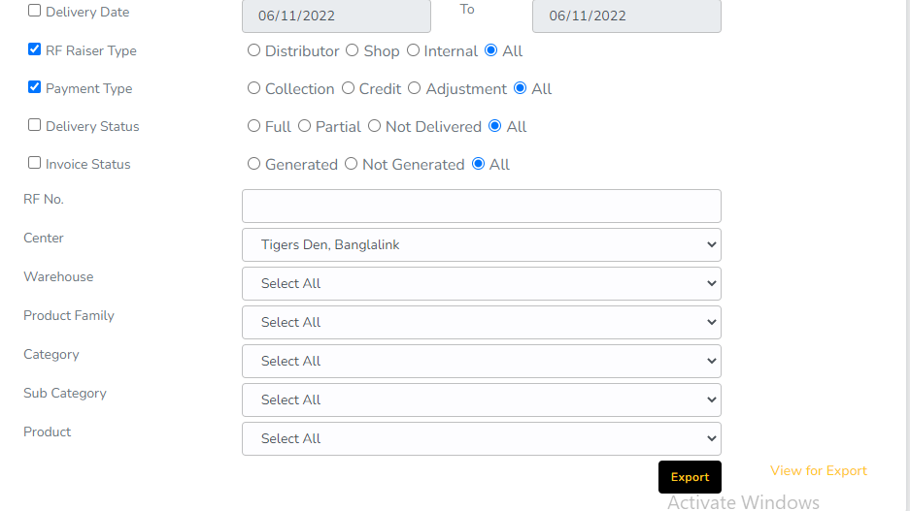1. Export button not working

2. View file export show below message

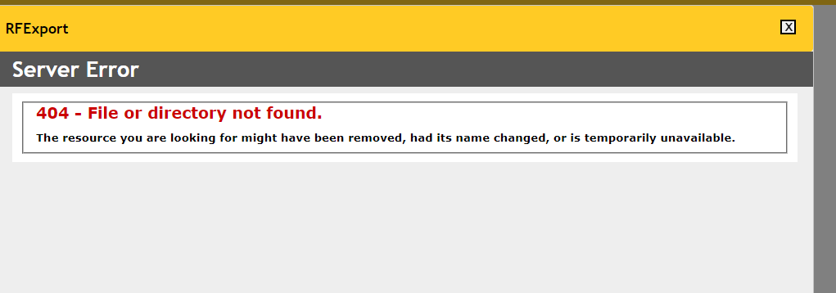

RFForApprovalMaster.aspx RF Approval

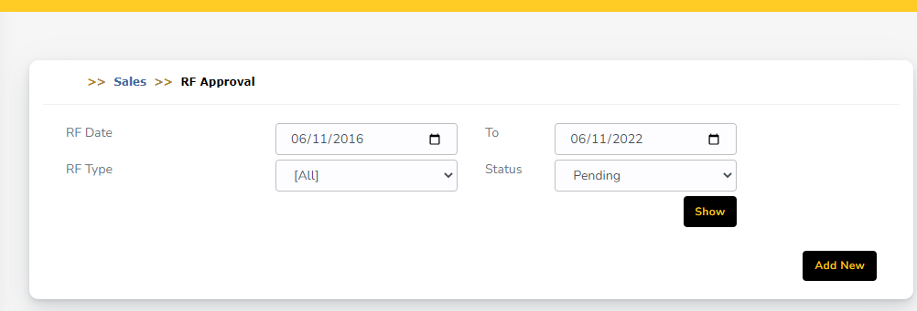

1. Show button is not working [Lots of issue found while inspect]

RF Add/Edit



1. RF Raiser Text box data not loaded, that’s way RF Code not visible
2. Could not perform Add button

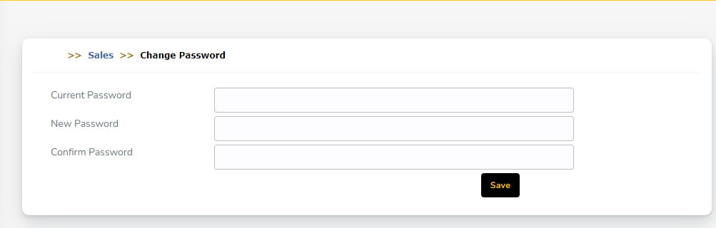ChangePassword.aspx

1. Save button not in right place
2. Not checking save button

RFMasterWarehouse.aspx warehouse Transfer RF

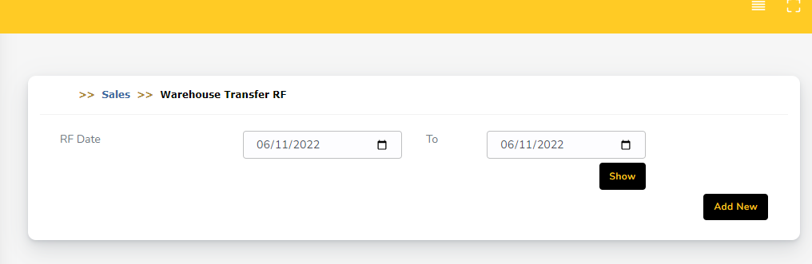

1. Show button is not working [Lots of issue found while inspect]

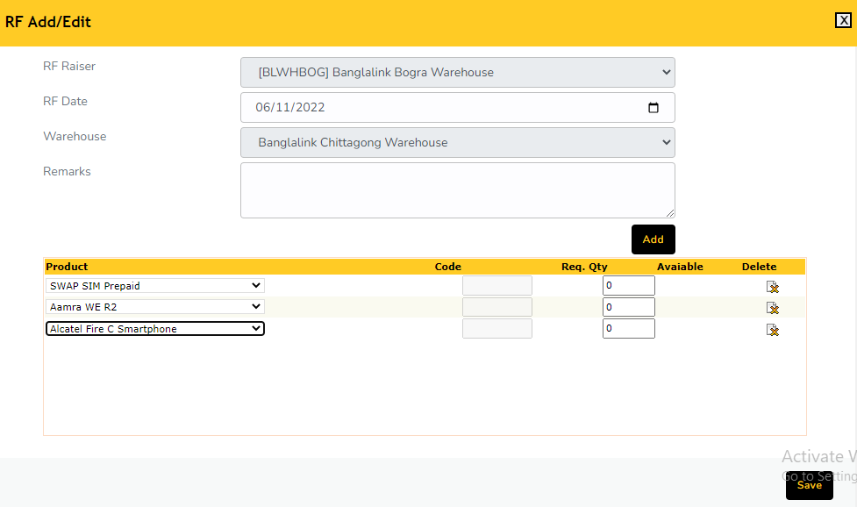

1. When select product Code & Available Qty not show
2. Data grid need to redesign
3. Not perform to save button

RFMasterCenter.aspx Center Transfer RF

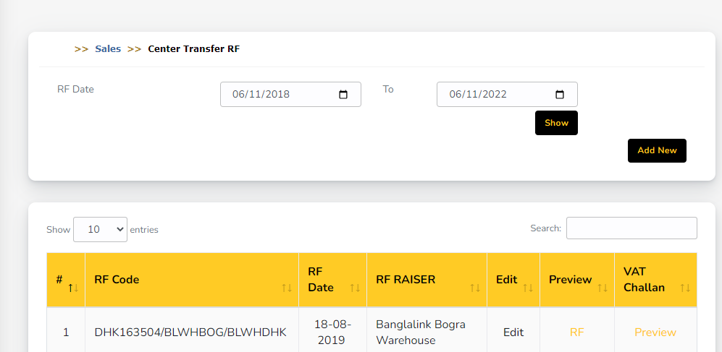

1. When click Preview RF & preview found Error Page
2. When click Add new

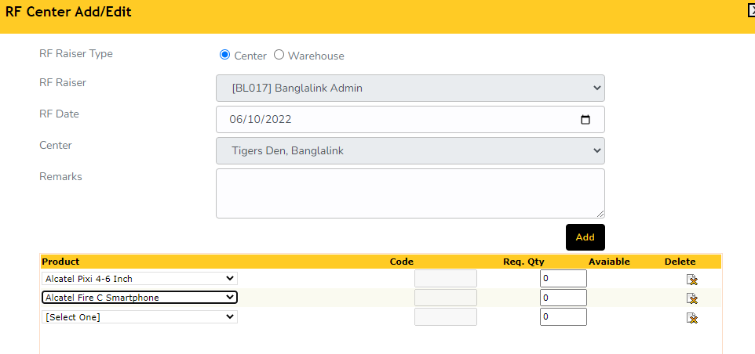

1. When select product Code & Available Qty not show
2. Data grid need to redesign
3. Not perform to save button

DMSInventorySync.aspx DMS Inventory Synchronization

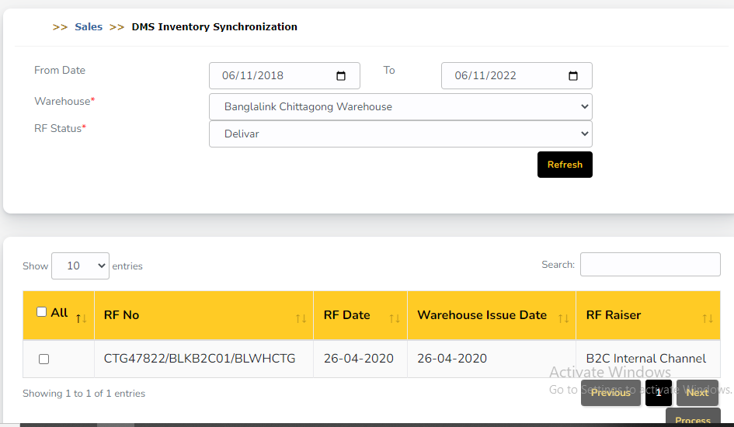

1. Process button need check

MapDistMobileNo.aspx Mapping distributor mobile no

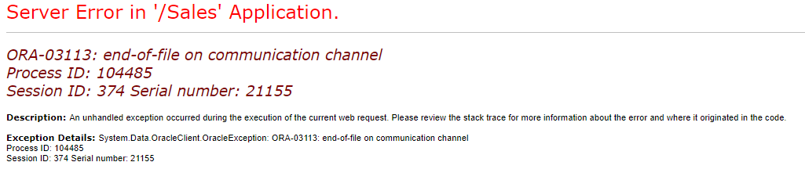

Collection

RFCollection.aspx Sales collection

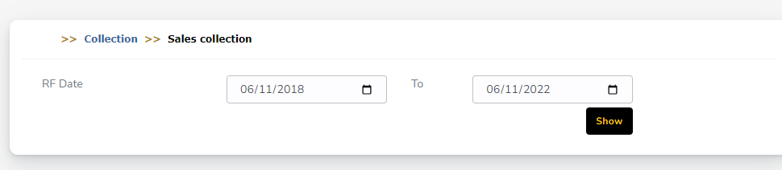

1. Show button is not working [Lots of issue found while inspect]
2. Could not perform next stage

Credit.aspx

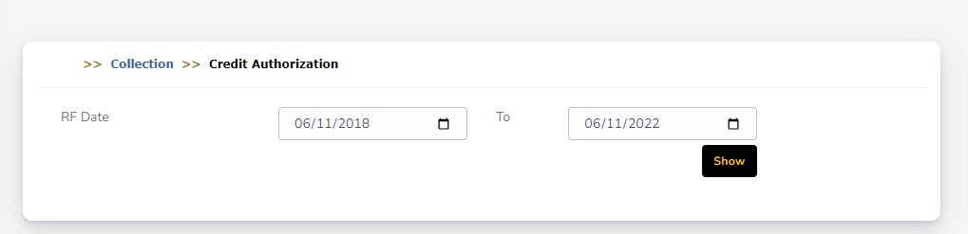

1. Show button is not working [Lots of issue found while inspect]
2. Could not perform next stage

CreditCollection.aspx 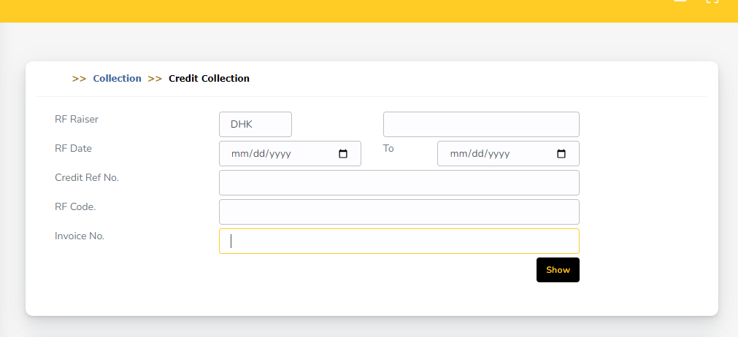

1. RF Raiser Text box data not loaded
2. Does not work show button
3. Cannot perform next step

Adjustment.aspx

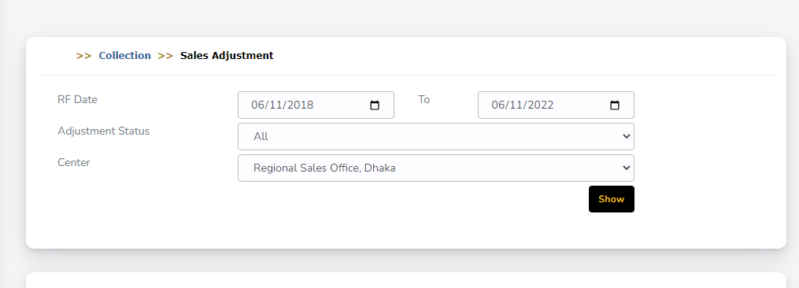

1. Show button is not working [Lots of issue found while inspect]
2. Could not perform next stage

Collection.aspx Collection list

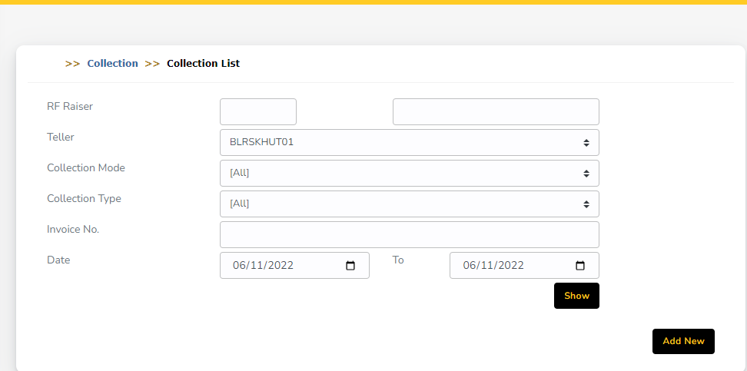

1. RF Raiser Text box data not loaded
2. Does not work show button
3. Cannot perform next step

DisbursementPending.aspx

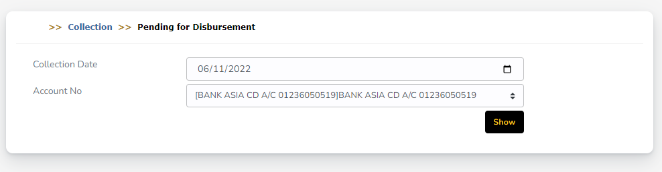

1. Show button is not working [Lots of issue found while inspect]
2. Could not perform next stage

Disbursement.aspx

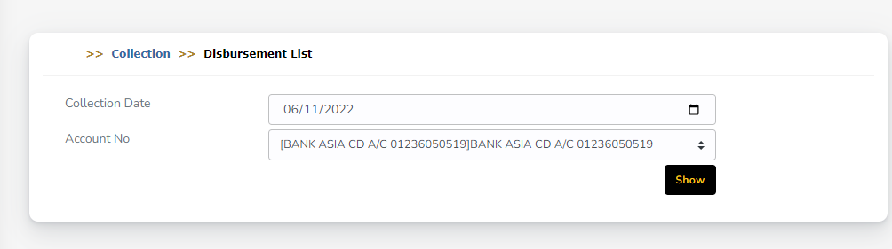

1. Show button is not working [Lots of issue found while inspect]
2. Could not perform next stage

TellerCashTransfer.aspx

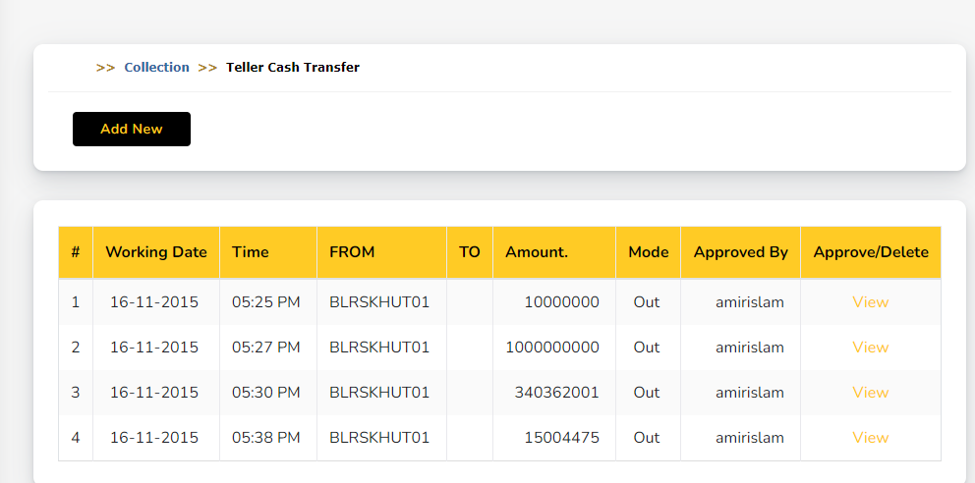

1. When click view no edit / add button show, need check business rules

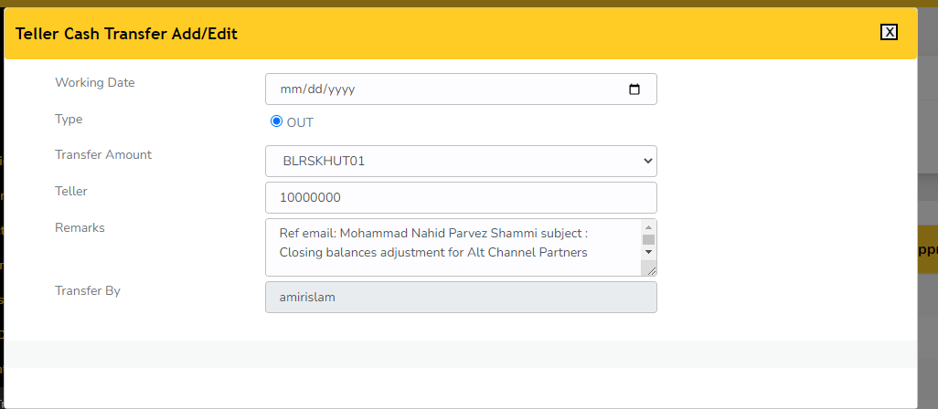

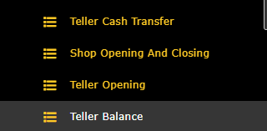

**Above items check with Arif**

**Distributor Balance**

PayableReceivableDistributor.aspx?type=P

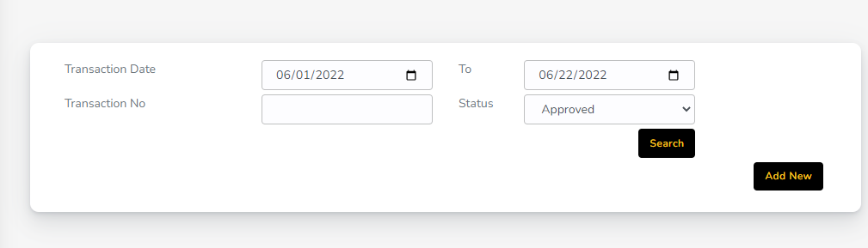

1. Search button is not working

Collectiondbm.aspx Collection List

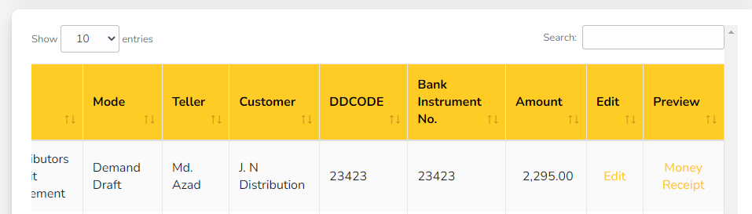

1. When click Edit no Edit button appear in edit page [Need to check old application & with Arif]
2. Money report does not work
3. When click Add button need to check proper data with Arif

rfmasterdbm.aspx Sales RF

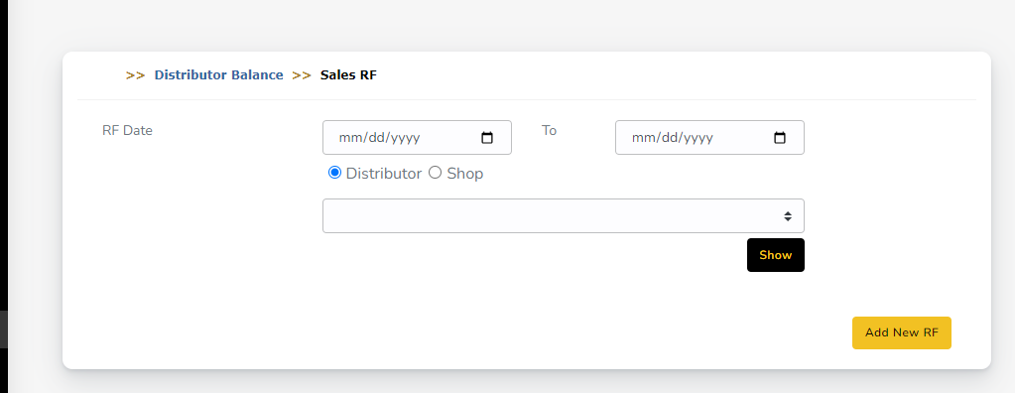

1.Need to check end to end with Arif

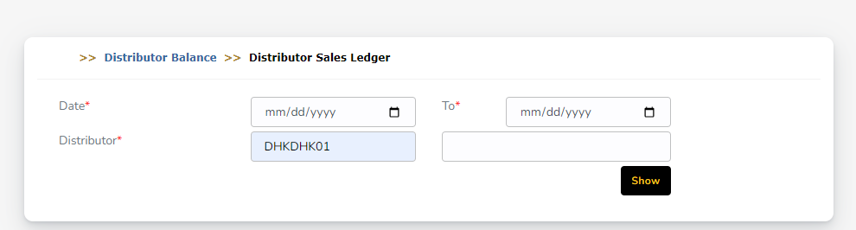

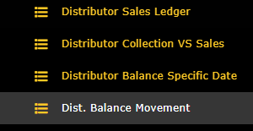

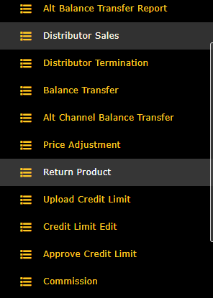

1. Above Menu All Distributor Text box data not loaded
2. Above pages need to check with Arif

**Delivery**

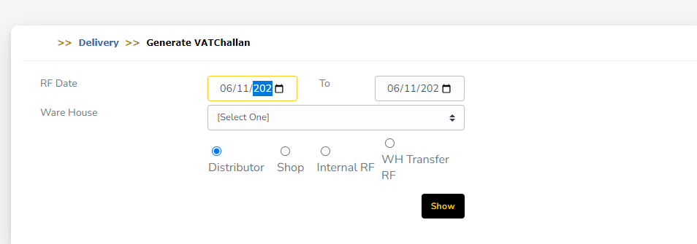

1. Date width should be increase
2. Show button is not working

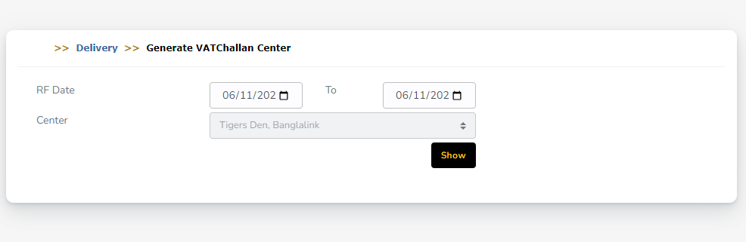

1. Date width should be increase

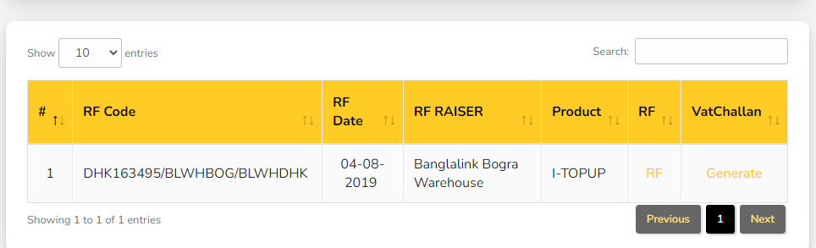

1. RF & Generate VAT challan not working

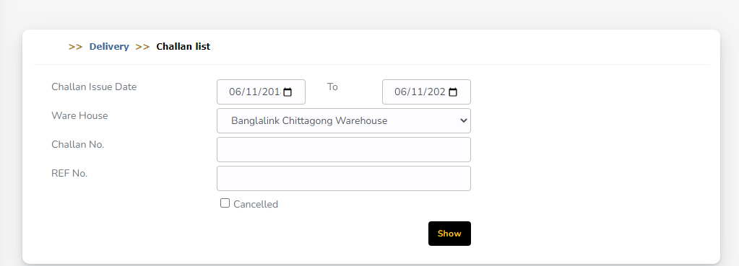

1. Date width should be increase
2. Show button is not working

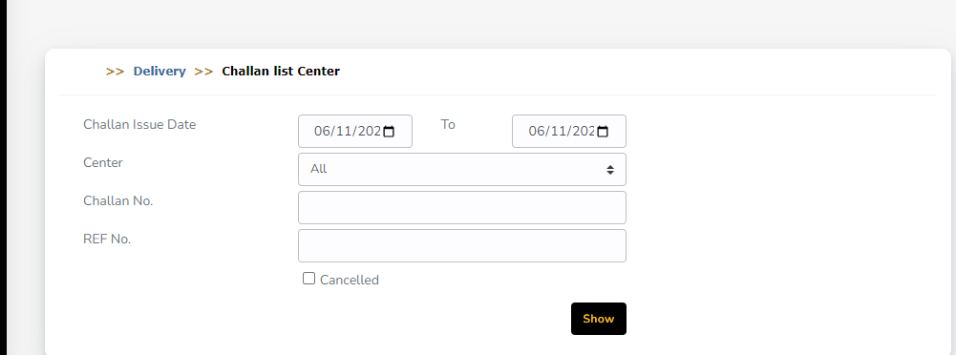

1. Date width should be increase

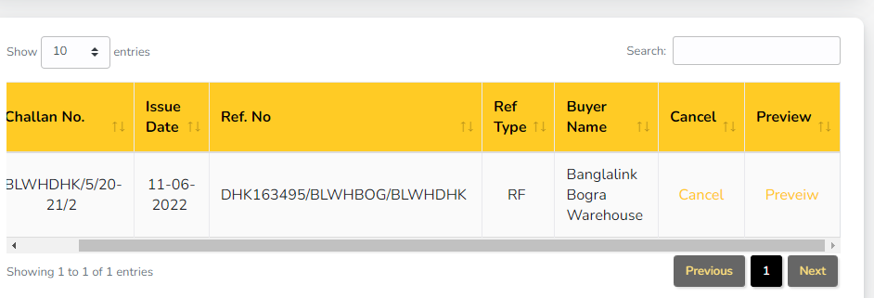

1. Preview is not working

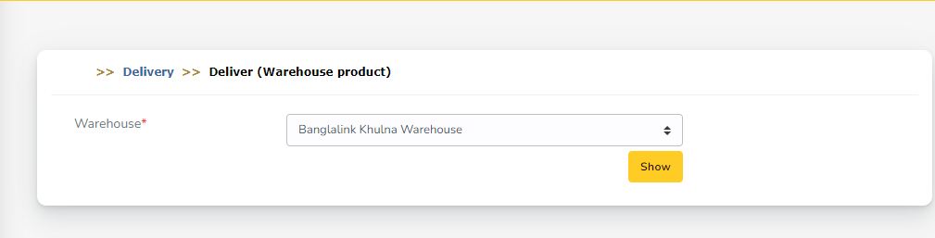

1. Show button is not working

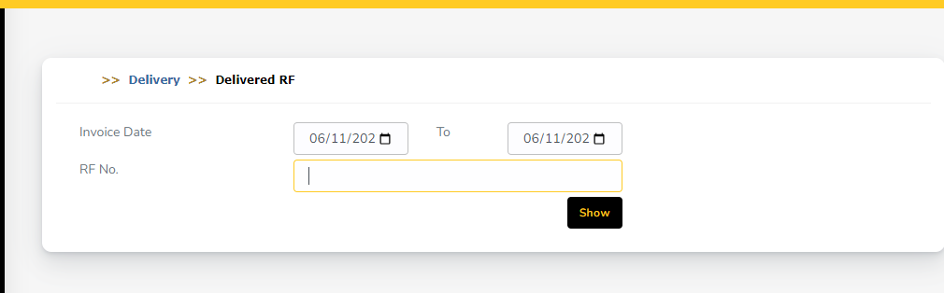

1. Date width should be increase
2. Show button is not working

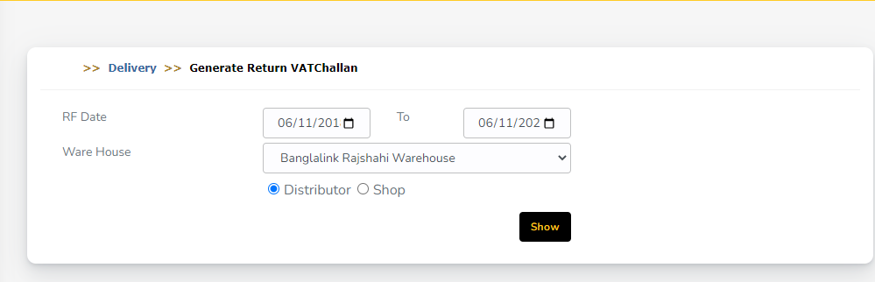

1. Date width should be increase
2. Show button is not working

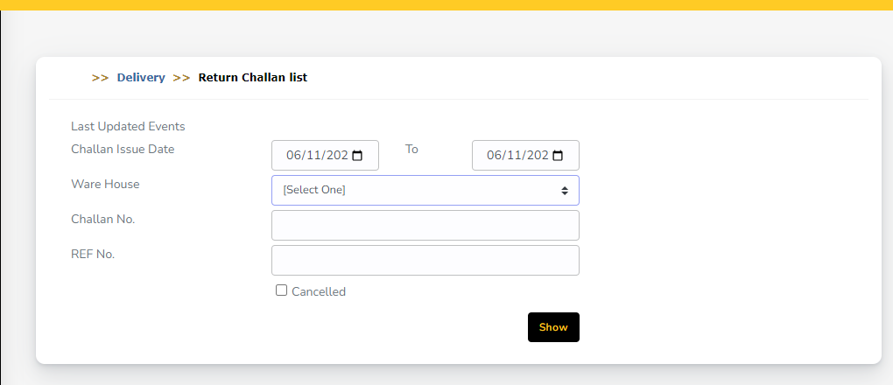

1. Date width should be increase
2. Show button is not working

**Reports**

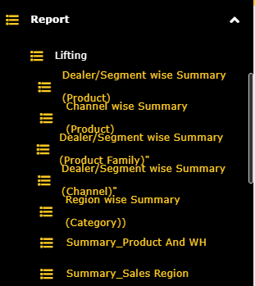

Menu Text format not right

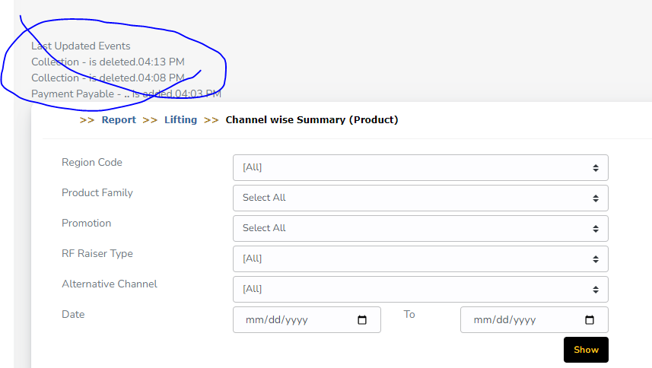

Need to check old application

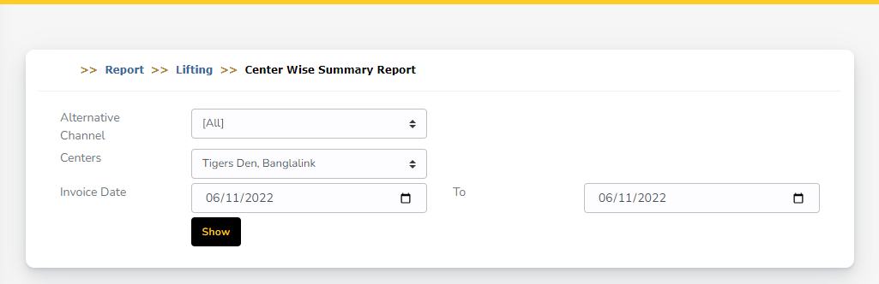

1. Show button should be right corner